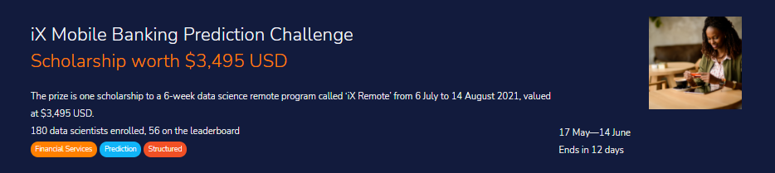

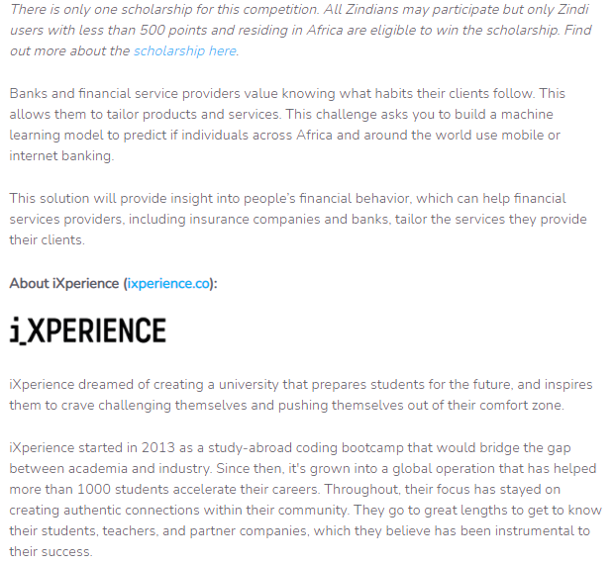

The train set contains ~100 000 and the test contains ~45 000 survey responses from around Africa and the world.

The objective of this challenge is to build a machine learning model to predict which individuals across Africa and around the world use mobile or internet banking.

**Files available for download:**

* **Train.csv** - contains the target. This is the dataset that you will use to train your model.
* **Test.csv-** resembles Train.csv but without the target-related columns. This is the dataset on which you will apply your model to.
* **SampleSubmission.csv -** shows the submission format for this competition, with the ‘ID’ column mirroring that of Test.csv and the ‘target’ column containing your predictions. The order of the rows does not matter, but the names of the ID must be correct.
* **VariableDefinitions.csv** - A file that contains the definitions of each column in the dataset. For columns(FQ1 - FQ37), Value 1 - Yes, 2 - No, 3 - Don’t Know 4 - refused to answer